AI ASSISTED CODING
ASSIGNMENT-6.4_1557
NAME:T.TEJASRI
HT NO:2303A51557
BATCH:09

Task 1: Student Performance Evaluation System
# Create method to display student details with attributes name,roll number,marks,pass or fail based on marks
class Student: def __init__(self, name, roll_number, marks):
self.name = name self.roll_number = roll_number self.marks = marks

def display_details(self):
status = "Pass" if self.marks >= 40 else "Fail" print(f"Name: {self.name}") print(f"Roll Number: {self.roll_number}") print(f"Marks: {self.marks}") print(f"Status: {status}")
# Example usage student1 = Student("Alice", 101, 85) student2 = Student("Bob", 102, 35) student1.display_details() student2.display_details()
#Create method to compare marks with class average using if-else
class Student: def __init__(self, name, roll_number, marks):
self.name = name self.roll_number = roll_number self.marks = marks def display_details(self):
status = "Pass" if self.marks >= 40 else "Fail" print(f"Name: {self.name}") print(f"Roll Number: {self.roll_number}") print(f"Marks: {self.marks}") print(f"Status: {status}")
def compare_with_average(self, average_marks): if self.marks > average_marks:
print(f"{self.name} has above average marks.") elif self.marks < average_marks:
print(f"{self.name} has below average marks.")
else:
print(f"{self.name} has average marks.")
# Example usage student1 = Student("Alice", 101, 85) student2 = Student("Bob", 102, 35) average_marks = 60 student1.display_details() student1.compare_with_average(average_marks)
student2.display_details()
student2.compare_with_average(average_marks)
OUTPUT:
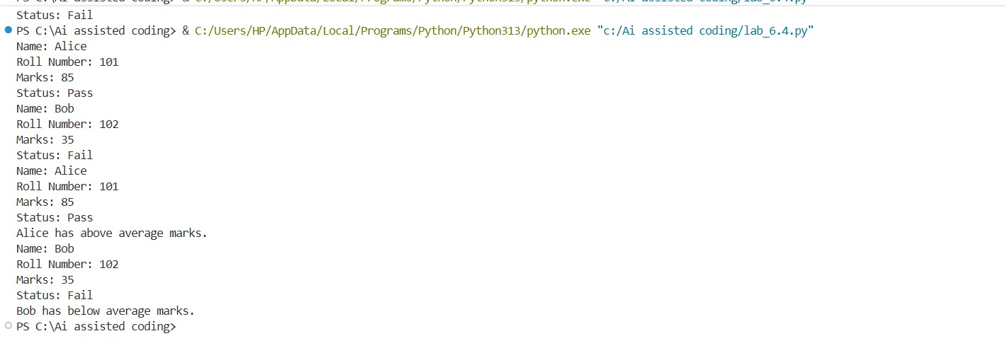
EXPLANATION: This task is about creating a Student class with basic details like name, roll number, and marks. Using Copilot, methods are added to display student details and compare marks with the class average using if-else.
Task 2: Data Processing in a Monitoring System
# Check if number is even using for loop if even print their squares
for num in range(1, 11): if num % 2 == 0:
print(f"{num} is even. Its square is {num ** 2}.")
OUTPUT:
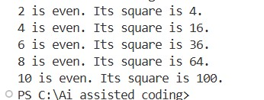
EXPLANATION:
This task focuses on using a for loop to check sensor readings. Copilot helps complete the logic to find even numbers, calculate their squares, and print them using conditions.
Task 3: Banking Transaction Simulation
#create a python class for bankaccount with methods to deposit,withdraw and check balance
class BankAccount: def __init__(self, account_holder, balance=0):
self.account_holder = account_holder self.balance = balance def deposit(self, amount): if amount > 0:
self.balance += amount print(f"Deposited: {amount}. New balance: {self.balance}")
else:
print("Deposit amount must be positive.") def withdraw(self, amount): if 0 < amount <= self.balance:
self.balance -= amount print(f"Withdrew: {amount}. New balance: {self.balance}")
else:
print("Insufficient funds or invalid withdrawal amount.") def check_balance(self):
print(f"Account holder: {self.account_holder}. Current balance: {self.balance}")
# Example usage account = BankAccount("John Doe", 1000) account.check_balance() account.deposit(500) account.withdraw(200) account.check_balance()
OUTPUT:

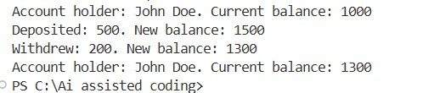
EXPLANATION: In this task, a BankAccount class is created with account holder and balance. Copilot generates methods for deposit and withdrawal, ensuring withdrawals are allowed only when enough balance is available.
Task 4: Student Scholarship Eligibility Check
#Define a list of dictionaries where each dictionary represents a student with name,score using while loop
students = [
{"name": "Alice", "score": 85},
{"name": "Bob", "score": 35},
{"name": "Charlie", "score": 60},
{"name": "David", "score": 45}
]
index = 0 while index < len(students): student = students[index] print(f"Name: {student['name']}, Score: {student['score']}") index += 1
#print names of student who scored more than 75 print("Students who scored more than 75:") index = 0 while index < len(students): student = students[index] if student['score'] > 75: print(student['name']) index += 1
OUTPUT:
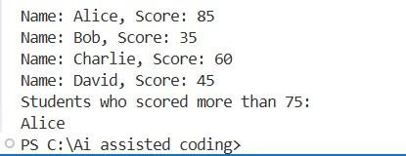
EXPLANATION:
This task uses a list of student dictionaries. With Copilot’s help, a while loop is created to check scores and print names of students who scored above 75.
Task 5: Online Shopping Cart Module
#writing a Python class named ShoppingCart with:An empty list to store items (each item may include name, price,quantity)
class ShoppingCart: def __init__(self): self.items = []

def add_item(self, name, price, quantity):
self.items.append({"name": name, "price": price, "quantity": quantity}) print(f"Added {quantity} of {name} at ${price} each to the cart.") def remove_item(self, name):
self.items = [item for item in self.items if item['name'] != name] print(f"Removed {name} from the cart.") def view_cart(self):
print("Shopping Cart Items:") for item in self.items:
print(f"{item['quantity']} of {item['name']} at ${item['price']} each") def calculate_total(self):
total = sum(item['price'] * item['quantity'] for item in self.items) print(f"Total cost: ${total}") return total
# Example usage cart = ShoppingCart() cart.add_item("Apple", 1.0, 5) cart.add_item("Banana", 0.5, 10) cart.view_cart() cart.calculate_total() cart.remove_item("Apple") cart.view_cart() cart.calculate_total()
# Methods to add items, remove items, view cart, and calculate total bill using a loop ,apply conditional discounts (e.g., discount if total exceeds acertain amount) class ShoppingCart: def __init__(self): self.items = [] def add_item(self, name, price, quantity):
self.items.append({"name": name, "price": price, "quantity": quantity}) print(f"Added {quantity} of {name} at ${price} each to the cart.") def remove_item(self, name):
self.items = [item for item in self.items if item['name'] != name] print(f"Removed {name} from the cart.") def view_cart(self):
print("Shopping Cart Items:") for item in self.items:
print(f"{item['quantity']} of {item['name']} at ${item['price']} each") def calculate_total(self):
total = sum(item['price'] * item['quantity'] for item in self.items) if total > 100:
discount = total * 0.1 # 10% discount
total -= discount print(f"Applied discount of ${discount:.2f}") print(f"Total cost: ${total:.2f}") return total
# Example usage cart = ShoppingCart() cart.add_item("Apple", 1.0, 50) cart.add_item("Banana", 0.5, 200) cart.view_cart() cart.calculate_total()
cart.remove_item("Apple") cart.view_cart() cart.calculate_total()
OUTPUT:
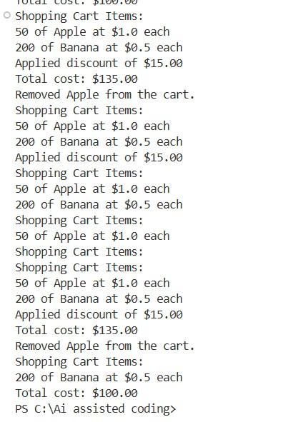

EXPLANATON: This task involves building a ShoppingCart class to manage items. Copilot helps create methods to add/remove items, calculate the total bill, and apply discounts using loops and conditions.

